**Rutgers University**

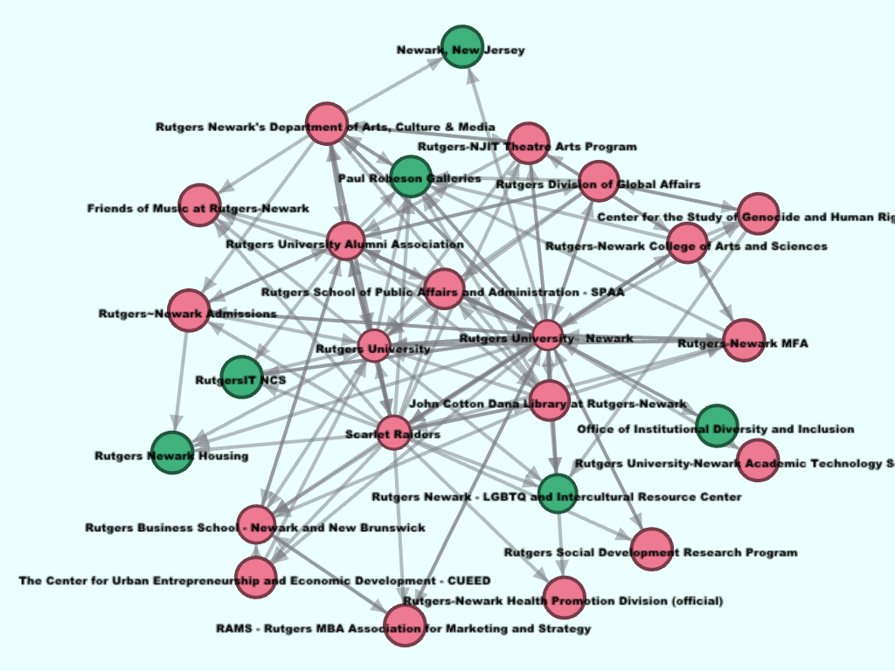**Analysis of page-like network of Rutgers University-Newark Facebook page**

**Rushi Modi**

**Applied Math 2**

**Prof. Chakrabarty**

**Due on March 14,2018**

**on Rutgers Blackboard**

The graph shown above in title page consists of Facebook pages that Rutgers University-Newark had liked and other pages that liked Rutgers Newark Facebook page so its page-like network of Rutgers University-Newark Facebook page. First, it took me some time on how to use gephi, but after getting the hang of it, I realized the importance of gephi in real life graph presentation. The above graph is a directed graph meaning that there is a direction to each connection, in our graph, one page might like the second page but the second page is not obligated to like another page.

I was able to download datasheet of Rutgers University-Newark page like network by using a netvizz application on Facebook. I had to use a site which converted a Facebook website into ID (a bunch of numbers), so it is easy for a netvizz to extract my data of given site/page. Also, since of Feb 5, 2018, Facebook has made many changes into netvizz after a lawsuit filed in Spain regarding privacy of users. This lead to many changed but one of the significant difference is that you can no longer extract data from your Facebook page to create social network chart or graphs for analysis. The data that I was able to retrieve from Facebook is in .zip format, after opening it on gephi, it consisted of 26 nodes and 124 edges. Each node represents the pages that Rutgers University-Newark Facebook page has liked and an edge represents a connection between each node. After I imported the graph, the first thing I did is, I arranged the graph in a way so I can better visualize the graph in gephi. After that, I tried multiple layouts to figure out the best layout to visualizes the better fit of my graph. After some trial, I finally decided to choose “Force Atlas 2” layout for my graph. In this paper, I will go over different graph partition visualization of various attributes such as fan_count, users_can post, post_activity, In-degree and out-degree and will explain what I did to make a graph 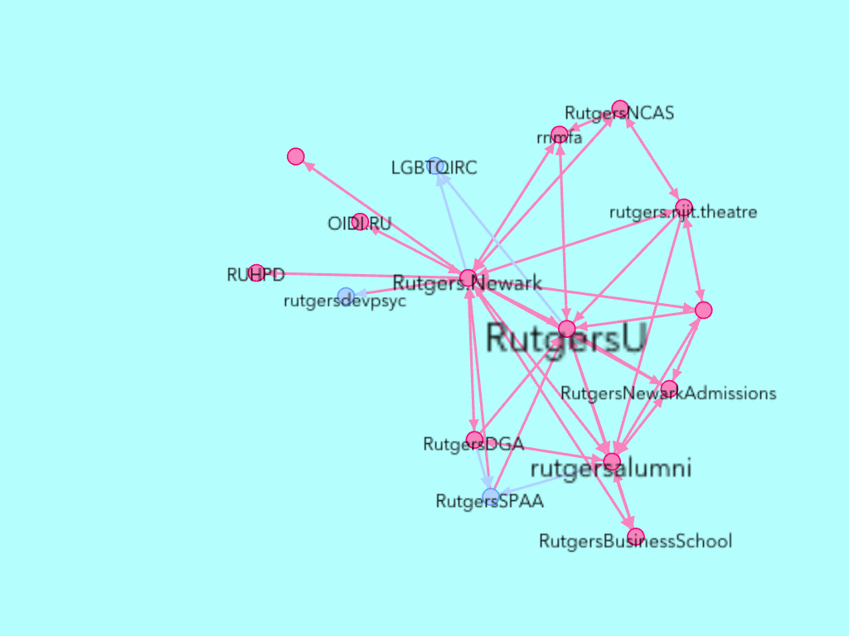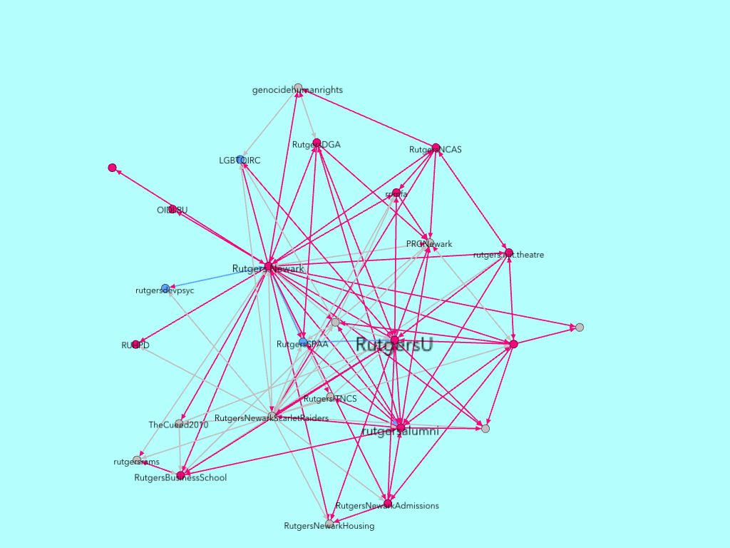more informative and just better.

Above, I have placed two graphs partitioned into two categories, 1. Colleges and universities with pink colored nodes and edges, 2. Schools with blue colored nodes and edges. All the other nodes and edges that are connected to it are not colleges, universities or schools. This two categories alone makes 62.5% of entire graph, which is seen on left graph and the right graph is partitioned into showing the only colleges/universities and schools. In this single above graph, I have colored all the other 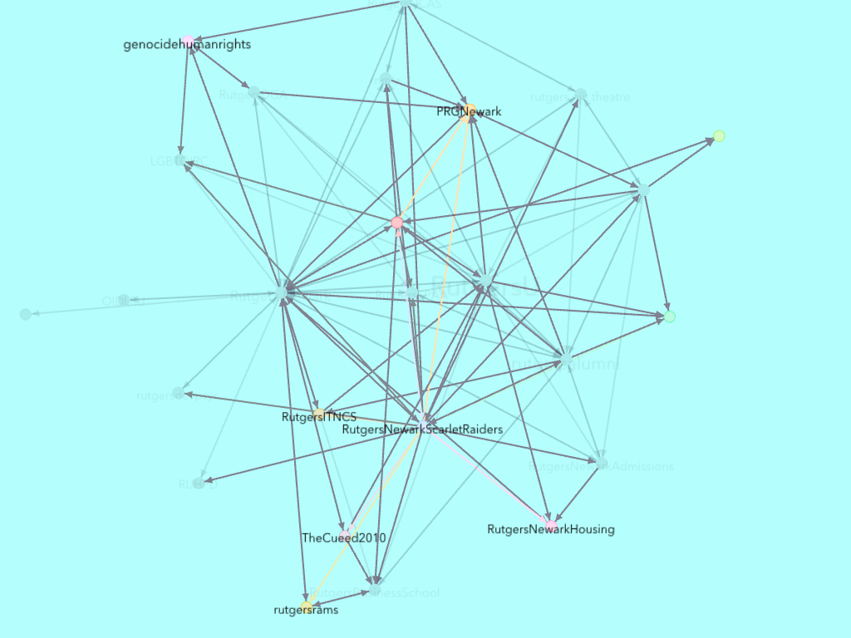facilities, nodes, and edges, that are not colleges/ universities or schools.

Now, we will go over fan_count attributes, so in a below-directed graph, I have assigned node sizes in regards to fan_count meaning more numbers of a fan_count of a particular Facebook page bigger the size of the node. Aso I have colored in a way where the blue-yellow-green-red refers in a range of lower to higher fan_count, so as you can see in the graph that Rutgers-University and Newark, New jersey facebook pages are two red nodes which means it consists of the highest fan_count, but to determine which one is larger amongst this two, you have to compare nodes size and we can clearly see that Newark, NJ is larger size of a node than Rutgers-University. This means that Newark, NJ has more fan_count than RU University facebook page. Also, if you notice, Newark, NJ has no red edges or connections that is directed towards any other node, unlike Rutgers- University node. This means that Newark, NJ node hasn’t liked any pages so there is no directional arc going to any other nodes. That is the reason why Newark, NJ 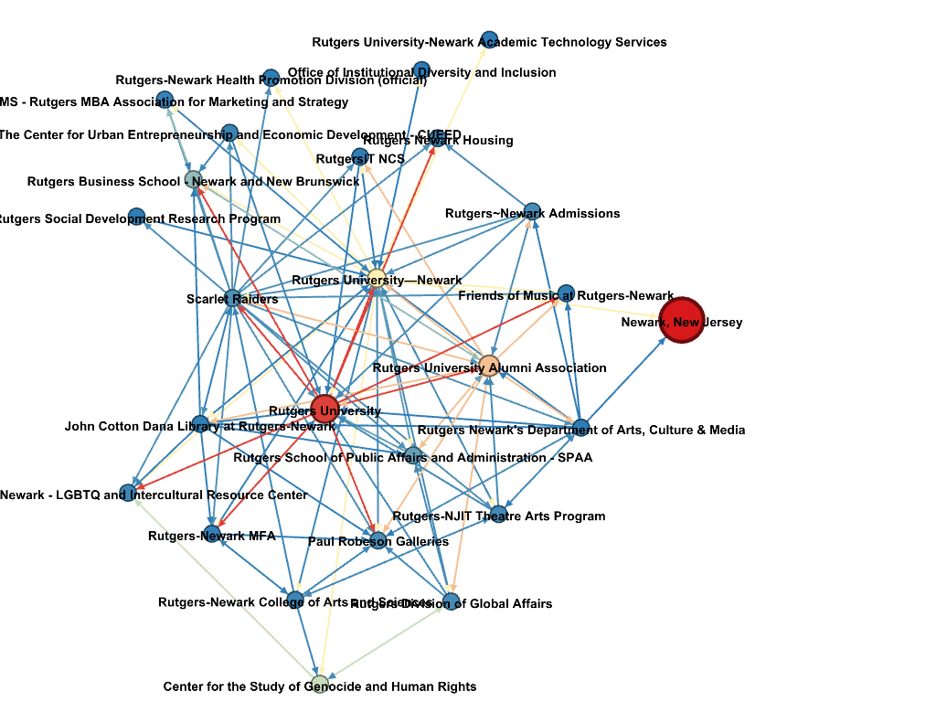does not have any red edges going to any other node.

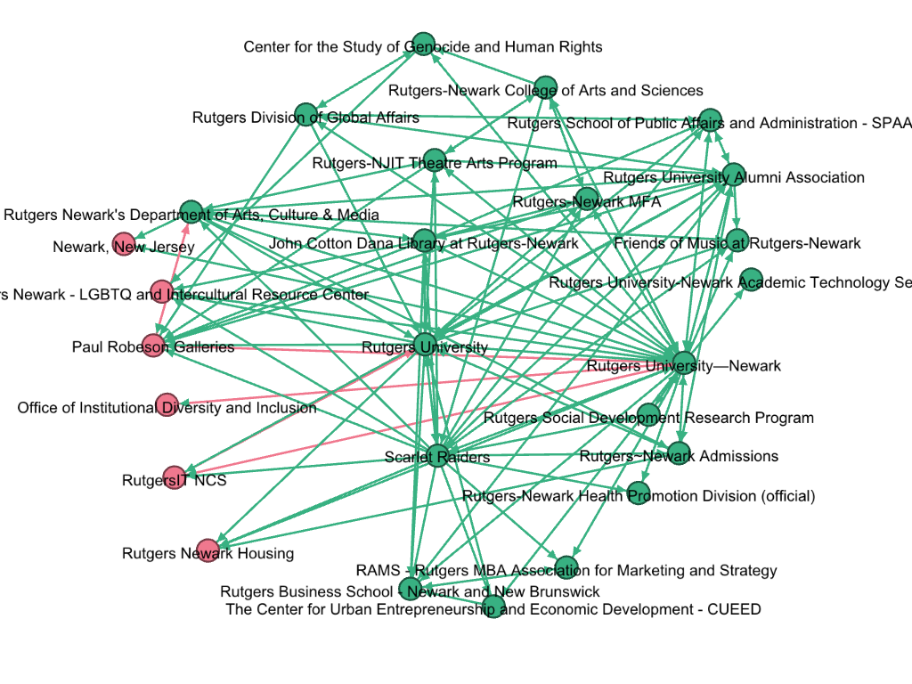Also, we will discuss which pages have access or are allowed to post on other pages. In the graph below, green color represents yes, users_can_post and pink color represent No, users_cant_post..

In above graph, I have arranged nodes in a graph so a left portion of the graph will represent all the red nodes that are not allowed to post on other nodes and the right portion of the graph consists of all green node that are allowed to post.

In below graph, I have assigned colors blue-yellow-orange-red with a range of lower to higher node degree. By visualizing, we can see that Rutgers University-Newark is colored red and is more prominent in size than all the other nodes meaning that it has the highest degree. Average Degree 4.769 with the range of 1 to 41.

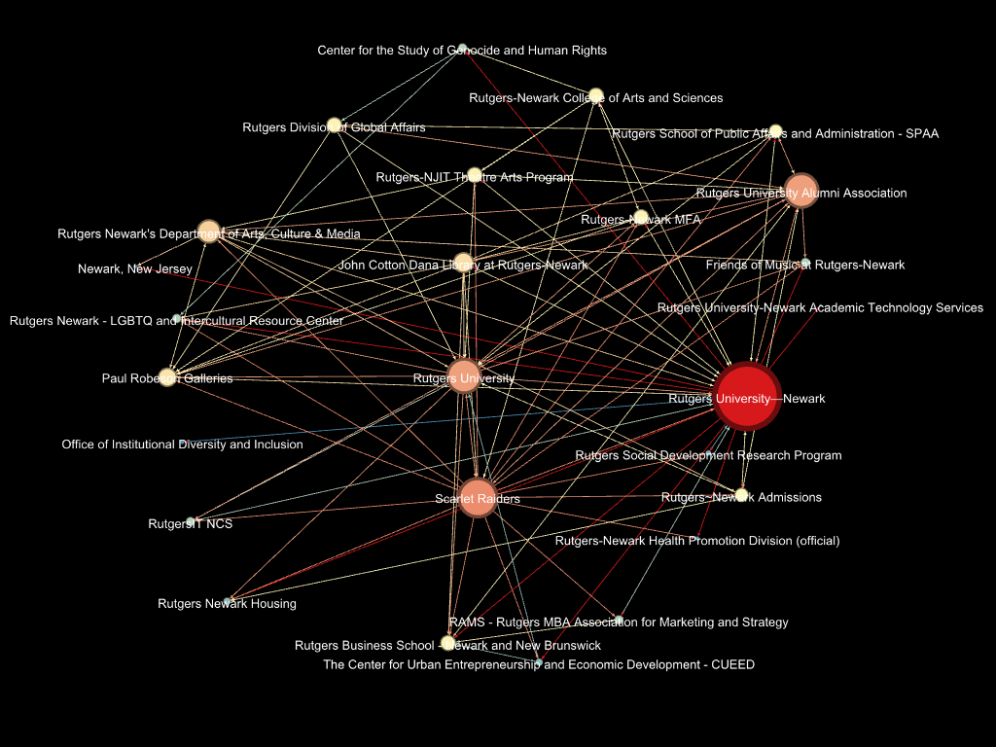

**Degree Report**

**Results:**

**Average Degree: 4.769**

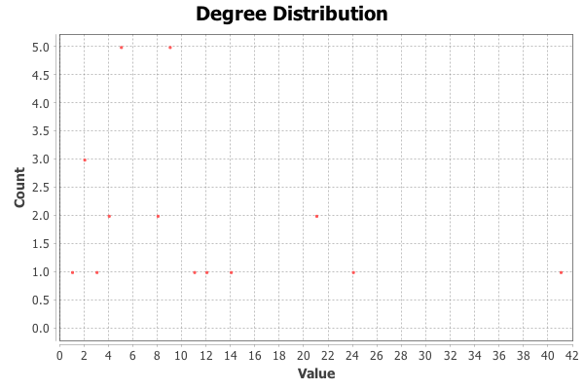

we will look into which node (Facebook page) is more active, by comparing to the time interval between each Facebook page and we will check it for the rate of post/ hour for last 50 posts on their Facebook page. The graph below provides us with that information where red nodes are very active, and orange nodes are less active than red nodes, and green nodes are less active than the orange nodes and blue nodes being least active amongst all other nodes, so Red>Orange>Green>Blue.

Rutgers University-Newark is the most active Facebook page amongst other Facebook pages.

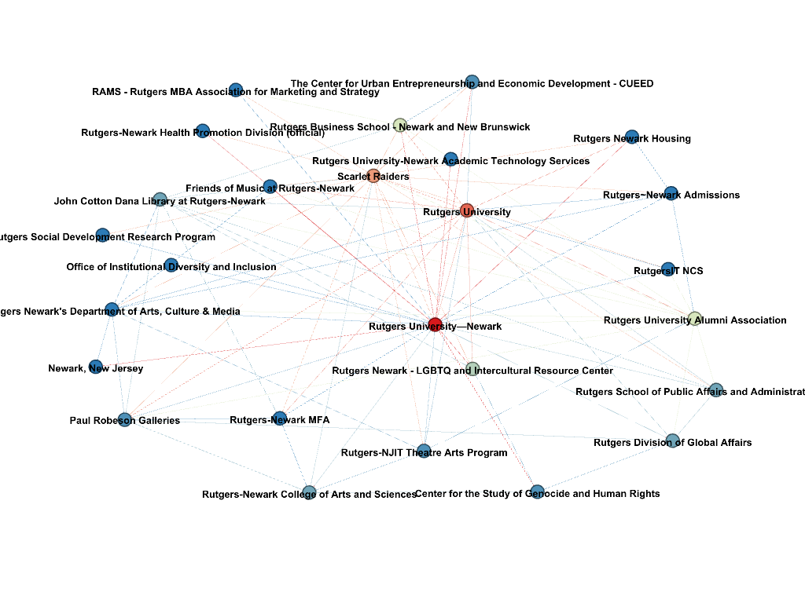

Conclusion:

It took me few days and roughly couple hours to become familiar with essential functions of Gephi. Since I am running Gephi on Mac OS, some features are not available such as 3D sphere nodes and many times Gephi would just crash or I would have to force quit the application since it would freeze. Nevertheless, I enjoyed learning and working with Gephi application. I am used to old ways of graphing such as a pie graph, bar graphs, and line graphs but working with Gephi was the best experience I have had with creating and dealing with data/graphs and just playing with the filter and so on. The only frustrating part that I found in gephi is that undo feature is not implemented in gephi. If this feature has been implemented then it would be easier to work with gephi instead of opening a new workspace and working from scratch when I want to undo my changes. But overall, apart from no Undo feature and crashes due to high memory usage by gephi application, I enjoyed working with Gephi and will most likely use it future. I knew or had a clue for apart from the one where Rutgers University-Newark FB page was more active in post activity than all the other pages. I honestly thought that Newark-NJ page should be more active since it has lot more fan_count but to my surprise I was wrong. It was a fun new experience working with gephi, and I enjoyed it very much. It's an excellent tool for making data/graph look more exciting and delicate with colors, etc.

References

Koehler, K. R. (2012). Directed Graphs. Retrieved March 12, 2018, from <http://kias.dyndns.org/comath/33.html>

(2016, October 10). Retrieved March 12, 2018, from <http://www.youtube.com/watch?v=mLOSLYNWmBA>

Rutgers University-Newark. (n.d.). Retrieved March 12, 2018, from <http://www.facebook.com/Rutgers.Newark>.

Slideshare.net. (2018). *Studying Facebook via Data Extraction: a Netvizz tutorial at the Digi…*. [online] Available at: <https://www.slideshare.net/digitalmethods/netvizz-netvizz-dmi13>

[Accessed 12 Mar. 2018].

7-Minute Data Analysis tutorial using Facebook Page Like Networks ... (2016, November). Retrieved from <https://www.linkedin.com/pulse/data-analysis-tutorial-using-facebook-page-like-networks-kupsch> [Accessed 12 Mar. 2018].

Srinivasan, S. (2017). *Guide to Big Data Applications*. , : Springer. <https://www.quora.com/What-is-the-indegree-and-outdegree-of-a-graph>

[Accessed 12 Mar. 2018].

Out Degree Sequence And In Degree Sequence - Mathonline. (n.d.). Retrieved from <http://mathonline.wikidot.com/out-degree-sequence-and-in-degree-sequence>

[Accessed 12 Mar. 2018].

Betweenness Centrality. (n.d.). Retrieved from <https://www.sci.unich.it/~francesc/teaching/network/betweeness.html>

[Accessed 12 Mar. 2018].